These pages are designed to show you how to use software packages; various software updates may have taken place so some pages will not apply to versions other than those listed here. In some cases data files may be required.

Title or Task: | Making a Dreamweaver Site Images    
Description: | Create a web site

Files Required
Suitable for Classes: | AIT • Multimedia • Cert II IT • Cert II Bus
Area: | Technology & Enterprise
Teacher: | Mr Peter Faulks
Timeline | 1 Lesson

Date Due:
Task Brief: | Create a folder (site) and first page
Outcomes: | Ability to use web authoring tool like Dreamweaver

Items highlighted in yellow are tasks for you to complete
Items in Blue italics are help tips

Background Full Screen Image
Place a background image on a web page that stays in one place whilst other content scrolls down
Find a nice background make the size 1200 x 800 or as close as possible to this


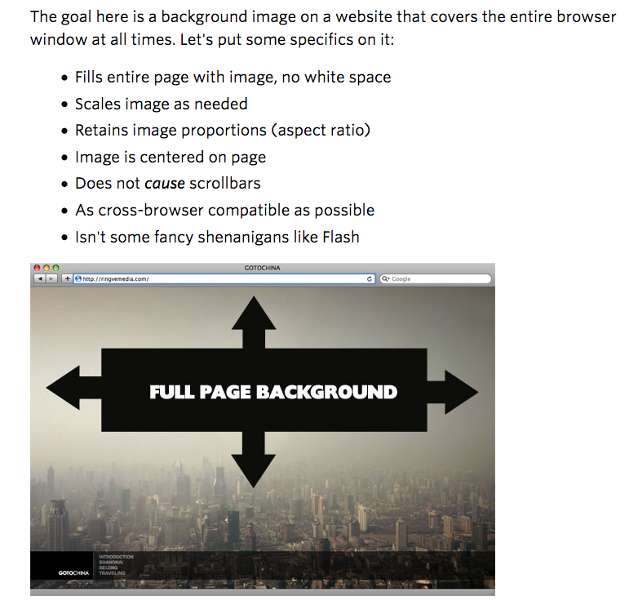
Step 1:
Once you have placed your image in Dreamweaver using the page properties button you will go to CSS Styles panel. If the panel is not open or doesn’t show on your screen you can simply go to Window> CSS Styles.
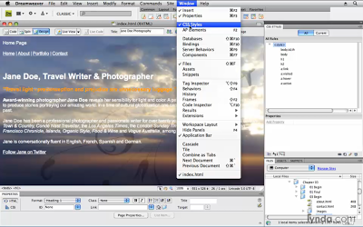
The box will appear in the upper right corner in Dreamweaver. The tab will say “CSS styles”
Step 2:
Select “body” inside of the CSS Styles box. This is simply done by double clicking on it.
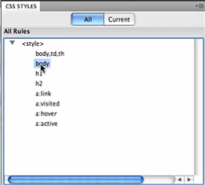
After double clicking “body” another box will appear that says, “CSS rule definition for body” at the top of the box.

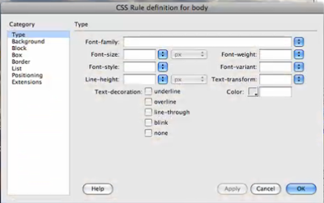
Step 3:
In the “CSS rule definition for body” box select the word “background” located on the left side of the box.
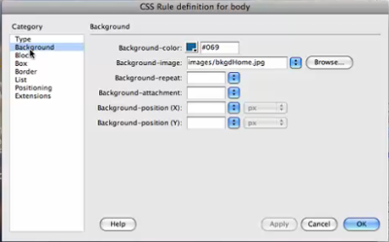
You will notice that your image info for your background image is already there as well as a background color.
Step 4:
In the option that says, “background-attachment”, select the word “fixed”.
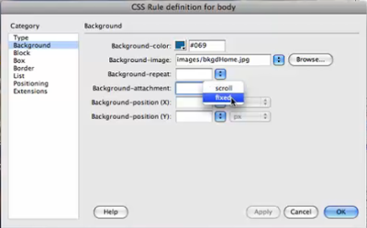
This is what allows the picture of the background to stay where it is while having the rest of y
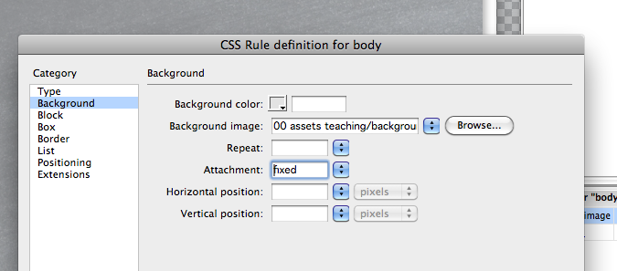our content or text able to scroll.
Step 5:
Now select the “background-position (x)” to “center.” Then press Apply.
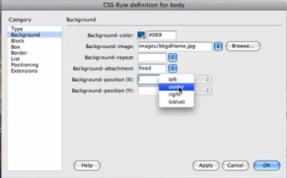
Step 6:
Lastly select “background-position (Y)” and choose “top”. And click apply again.
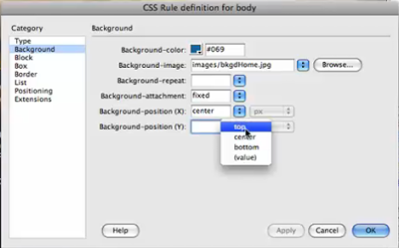
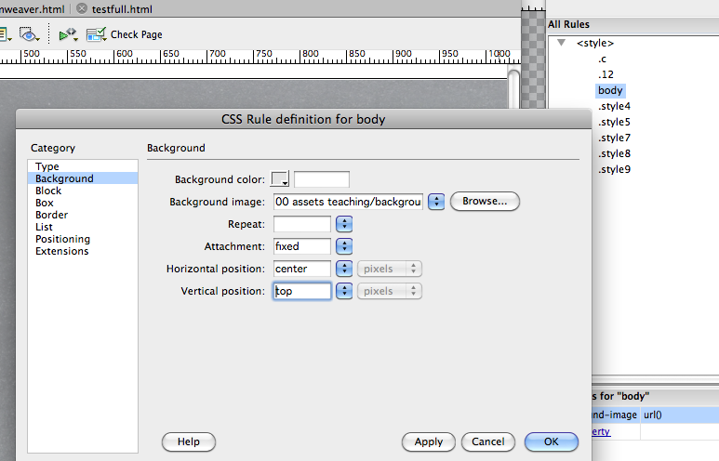
This changes the vertical position of your image. In this case selecting “top” makes sure that your background image will be located at the top of the page.

Step 7:
Once all of these options have been chosen, go ahead and click ok.

You’ll notice that your background image has been moved and centered.

Code
body { background-image: url(00%20assets%20teaching/background_chalkboard50.jpg); background-attachment: fixed; background-position: center top;}

Location of background image/the image being used

body { background-image: url(00%20assets%20teaching/background_chalkboard50.jpg); background-attachment: fixed; background-position: center top;}

Tip put an image that you wish to use onto your web page in Dreamweaver then from code copy the location and image to the above code

The in design remove the image





